**Capstone Project Option #2 - Business Intelligence Solution for International Organization**

Mickayla Sujkowski

Colorado State University Global

MIS480: Capstone – Business Analytics and Information Systems

Dr. Kimberly Ford

September 12, 2021

**Capstone Project Option #2 - Business Intelligence Solution for International Organization**

A business intelligence tool is only helpful if the information revealed to the organization is of value. An organization must be sure the tool will add value and better inform decision-makers before implementing the tool. Unfortunately, many organizations do not receive the expected benefits once the system is implemented, as using a business intelligence tool does not guarantee success or competitive advantage (Moreno et al., 2018). Before Universal Music Group implements its new business intelligence tool, the organization must identify the business problem, determine relevant data, understand the tool, and identify outcomes and benefits.

**Background and Problem Identification**

Universal Music Group is the world’s largest music company. The company’s corporate headquarters are in Hilversum, Netherlands, and its operations headquarters are located in Santa Monica, California but has offices in more than 60 countries internationally (Universal Music Group [UMG], 2020). Universal Music Group has many labels and brands, including Republic Records, Cash Money Records, Decca Records, Capitol Studios, Universal Music group Nashville, and Virgin Music Label and Artist Services (UMG, 2020). This organization was chosen in response to a personal love for music and analytics. Universal Music Group combines two personal interests and makes completing this business intelligence solution presentation even more enjoyable.

The music industry is further behind than other industries in adapting to the always-changing digital landscape, requiring organizations like Universal Music Group to look for outside help to stay competitive in the market (Parry et al., 2014). To stay competitive in the music industry, Universal Music Group needs to understand where to apply the most robust marketing strategies and in what way to market. Knowing which record labels, genres, or artists are most popular, along with what labels are receiving the most RIAA certifications, will assist Universal Music Group in more strategically making its marketing decisions.

Universal Music Group, or UMG, would like to know where investments and purchased assets are most often turned into revenue. For example, UMG executives would like to know which record labels, artists, and genres are most profitable. The industry is relying more each day on technology as “music is increasingly frequently recorded using digital technology, mixed and mastered using digital technology, and distributed on digital media” (Clemons et al., 2002, p. 19). Music industry competitors must collect and analyze market information to make decisions and understand the decisions of others in the industry (Anand & Peterson, 2000). Understanding this information through analyses can help executives increase profit and better allocate funds and efforts.

**Working with the Data**

The dataset utilized for this project consists of nine tables which can be seen in the relational diagram in Figure 1. The Universal Music Group dataset was created using a dataset from David DeFoe (2020) of data on songs from Billboard 1999 to 2019 combined with a dataset created manually of Universal Music Group’s record labels with each artist that belongs. The dataset retrieved contains eight tables: Artist, BillboardHot100, GrammyAlbums, GrammySongs, riaaAlbumCerts, riaaSingleCerts, songAttributes, and spotifyWeeklyTop200Streams (DeFoe, 2020). To make the data more relevant to the Universal Music group specifically, another table of over 3,000 rows was created manually to outline all the record labels contained in each of Universal Music’s Groups and each artist with a contract with the subsequent record label. This manually created table is named Labels. This creates the tie between the obtained Billboard and RIAA data and Universal Music Group data. Every table or entity with its corresponding attributes can be seen in Figure 2. Entity names are shown in bold, while primary keys are underlined. This dataset can inform Universal Music Group which labels, artists, albums, or even songs perform the best within the organization and industry.

**Figure 1**

*Universal Music Group Dataset Relational Diagram*

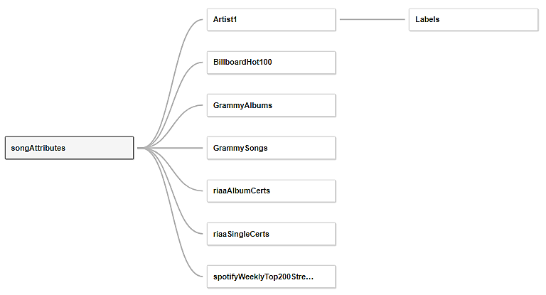

*Note.* Created using Tableau desktop.

**Figure 2**

*Universal Music Group Dataset Entities, Attributes, and Keys*

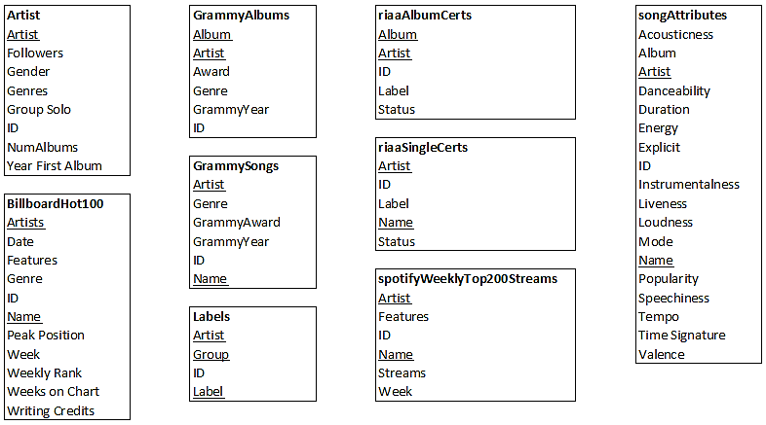

*Note.* Created using Microsoft Excel.

Universal Music Group will utilize Microsoft SQL Server Express to store its data. The data will then be accessed, manipulated, and updated using Microsoft’s SQL Server Management Studio. Microsoft SQL Server Express is a free tool. Because Microsoft SQL Server Express and SQL Server Management Studio are free, any organization that can learn how to use it and apply it will undoubtedly bring value to the organization. SQL Server Management Studio is the most common tool used to manage SQL Server Express databases and is relevant as it is often applied in academia and corporations alike (Ilić et al., 2021). Many online documents and forums can help support Universal Music Group while implementing SQL Server Express and SQL Server Management Studio.

**Understanding and Learning Tableau**

Tableau is a drag-and-drop, or low to no code, software that makes it easily understood by business professionals outside of the Information Technology department. Users do not need to understand programming or statistics in-depth to use the tool, making it ideal for Universal Music Group. Business intelligence focuses on describing the behavior of data, and Tableau is a solid and successful tool in executing such descriptive analyses (Baader & Sattler, 2001). Business intelligence can be used by users in many different departments of an organization, not just information technology or analytics. Tableau is being implemented in organizations of all types and sizes, including in Big Data environments, and is a good tool for any individual trying to comprehend data relationships and trends, regardless of volume (Murray, 2016).

Tableau can integrate some programming languages such as R and Python, but it is more commonly utilized through its drag-and-drop capabilities. Before a user begins analysis, Tableau needs to connect to the necessary data. Tableau allows users to search for data, upload a file, connect to a server, or use a saved data source. Once the connection is established, the tables the user would like to use for the analysis are dragged to a new area where relationships need to be defined so Tableau can determine the importance of the data. The user can then open a new sheet where the data tables and attributes are listed on the furthest left panel. The attributes can then be dragged and dropped to be specified as columns, rows, or filters. Marks can also be used to customize the visualization further.

Tableau offers many different visualizations to display data analysis results. These options include interactive charts, graphs, dashboards, and worksheets for business insights (Kaur, 2017). These data visualizations can help Universal Music Group better understand which demographic groups are listening to their music and where the most units are being sold. Scatterplots can be used to analyze the correlation between demographic variables. Histograms can help compare the counts of data between different labels. These can then be used to predict loyalty to a brand, artist, or genre within Universal Music Group, which is essential as brand loyalty focuses on marketing and consumer behavior (Chang & Lewis, 2009). They can also be used to present the highest-earning artists, labels, songs, and more. With the necessary data, the opportunities are limitless.

**Benefits of Business Intelligence and Outcomes of Analysis**

The use of business intelligence can forever change how an organization makes decisions. Many of the available tools can be learned relatively quickly but are still versatile and have many opportunities. Organizations can identify where costs can be cut or where it may be beneficial in increasing funding. Visualizations help stakeholders and management better understand what is occurring within the business without worrying about the data. Business intelligence tools help organizations better create reports and visualizations to help others better understand the activity affecting and surrounding it. Although business intelligence is descriptive, not predictive, information found can still predict future activity. Overall, business intelligence can assist in proactivity and anticipating needs, mitigating risk and fraud, delivering relevant products, personalization and service, and optimizing and improving customer experience (Ahmad, 2018).

Two example analyses have been conducted to present the intelligence that can be gained through such. The three most common release types in the music industry are albums, singles, and extended plays or EPs. Of these three release types, singles have the highest potential to be recognized by consumers (Essling et al., 2017). When examining the Universal Music Group dataset, riaaSingleCerts and Labels can be combined to understand better which labels are performing the greatest. RIAA stands for the Recording Industry Association of America. Unlike the book industry or film industry, there is no data on the return record labels received from its released music (Osborne, 2014). Because of the data available, analyzing RIAA Certifications will give a good idea of the success of music singles. The following analysis will show Universal Music Group the count of RIAA Certifications each of its labels has received.

The attribute CNT(riaaSingleCerts) is created using the riaaSingleCerts table and is assigned using Tableau to be shown graphically as rows. The attribute Label from the Label table is then assigned to be the columns. A filter is also placed upon the Label attribute only to show the value in the visualization if the corresponding riaaSingleCerts value is greater than zero. This filter removes any data points that are not relevant. The corresponding visualization can be seen in Figure 3. The visualization clearly shows that Universal Publishing Production Music has the greatest number of RIAA single certifications, followed by EMI and Bravado.

**Figure 3**

*Histogram Comparing Count of RIAA Single Certification by Record Label*

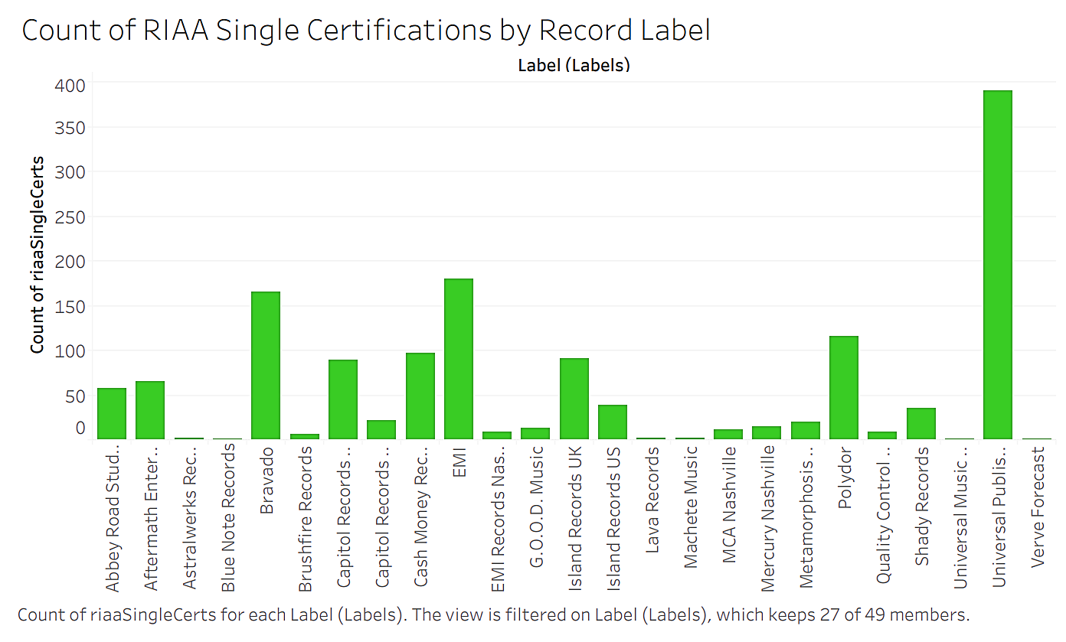

*Note.* Created using Tableau desktop.

Another analysis Universal Music Group may be interested in is the performance of a particular artist over time. This can help UMG determine whether it would like to renew an artist’s contract or update the contract when the time comes. One way to do this is by creating a time series line graph showing how many streams the artist has on Spotify over the given time frame. To complete this task and analysis, the attribute of Week from the spotifyWeeklyTop200Streams table is assigned to be the column value. The sum of Streams from spotifyWeeklyTop200Streams is then assigned to be the rows. The artist Demi Lovato has been chosen for this analysis. Therefore, a filter is created on the attribute Artist from the Artist table to specify that only data on Demi Lovato is shown. The resulting visualization is shown in Figure 4. Figure 5 shows the upload of these two analyses to Github showing the attributes, columns, rows, and filters used. Additionally, the database tables used have been uploaded to github in a CSV format within a zipped folder, also shown in Figure 5.

**Figure 4**

*Time Series of Spotify Streams by Week for Demi Lovato*

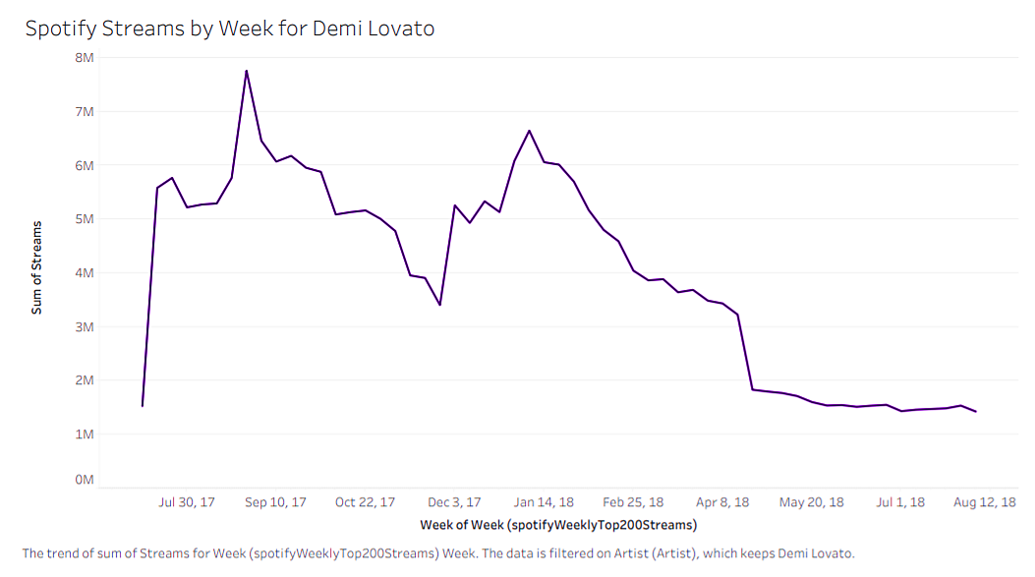

*Note.* Created using Tableau desktop.

**Figure 5**

*Github Upload of Sample Analyses and Data Used*

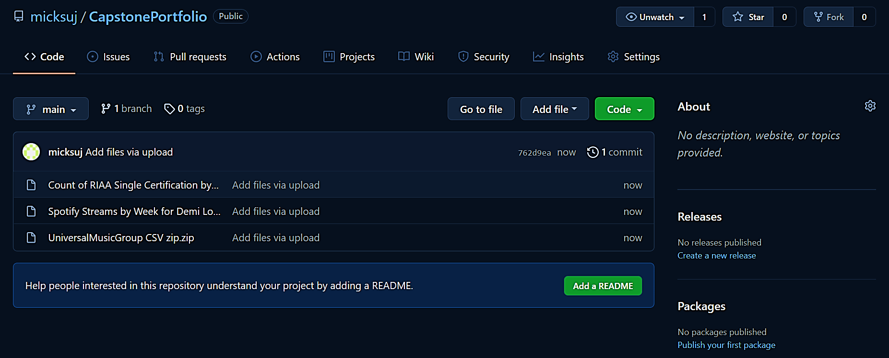

**Conclusion**

Now that Universal Music Group better understands how business intelligence tools can be utilized and how Microsoft SQL Server Express and Tableau can benefit the organization, it is hoped UMG will choose to implement the presented solution. The tools can aid in better decision-making regarding asset purchasing, marketing efforts, contract renewal, and much more. SQL Server Express is an free tool that is easy to learn, and Tableau is a user-friendly drag-and-drop tool with intuitive functions. These tools can be used in conjunction to perform analyses such as those seen. After considering all of the potential opportunities from utilizing these tools, UMG is urged to adopt this solution.

**References**

Ahmad, Y. (2018, March 7). *5 benefits of data analytics for positive business outcomes*. 5

Benefits of Data Analytics for Positive Business Outcomes. Retrieved September 12, 2021, from https://www.teradata.com/Blogs/5-Big-Benefits-of-Data-and-Analytics-for-Positive-Business-Outcomes.

Anand, N., & Peterson, R. A. (2000). When market information constitutes fields:

Sensemaking of markets in the commercial music industry. *Organization Science*, *11*(3), 270–284. https://doi.org/10.1287/orsc.11.3.270.12502

Chang, J., & Lewis, C. (2009). Loyalty in Media Sharing Websites: The Case of Universal

Music Group. *Journal of Internet Business*, (7), 21–41.

Clemons, E. K., Gu, B., & Karl Reiner Lang. (2002). Newly vulnerable markets in an age

of pure information products: An analysis of online music and online news. *Journal of Management Information Systems*, *19*(3), 17–41. https://doi.org/10.1080/07421222.2002.11045738

*Contact Universal Music Group*. Universal Music Group. (2020, November 12).

https://www.universalmusic.com/contact-us/.

DeFoe, D. (2020). Kaggle Database. https://www.kaggle.com/danield2255/data-on-songs-from-

billboard-19992019.  
Essling, C., Koenen, J., & Peukert, C. (2017). Competition for attention in the digital age: The

case of single releases in the recorded music industry. *Information Economics and Policy*, *40*, 26–40. https://doi.org/10.1016/j.infoecopol.2017.05.002

Ilić, M., Kopanja, L., Zlatković, D., Trajković, M., & Ćurguz, D. (2021). Microsoft SQL Server

and Oracle: comparative performance analysis. *The 7th International Conference: Knowledge Management and Informatics*, 32. https://www.researchgate.net/profile/Dragan-Zlatkovic/publication/352348811_MICROSOFT_SQL_SERVER_AND_ORACLE_COMPARATIVE_PERFORMANCE_ANALYSIS/links/60c43847a6fdcc2e613650dc/MICROSOFT-SQL-SERVER-AND-ORACLE-COMPARATIVE-PERFORMANCE-ANALYSIS.pdf.

Moreno, V., Vieira da Silva, F. E. L., Ferreira, R., & Filardi, F. (2019). Complementarity as a

driver of value in business intelligence and analytics adoption processes. *Revista Ibero-Americana de Estratégia (RIAE)*, *18*(1), 57–70. https://doi.org/10.5585/ijsm.v18i1.2678

Osborne, R. (2014). The gold disc: one million pop fans can’t be wrong? *Civilisations*, *13*, 159–

178. https://eprints.mdx.ac.uk/14066/.

Kaur, P. (2017, July 27). *Tableau tutorial for beginners: Data visualization Tableau*. Analytics

Vidhya. https://www.analyticsvidhya.com/blog/2017/07/data-visualisation-made-easy/#:~:text=Tableau%20is%20a%20Data%20Visualisation,simple%20as%20drag%20and%20drop!

Murray, D. G. (2016). *Tableau your data!: Fast and easy visual analysis with Tableau Software*.

Wiley.

Parry, G., Vendrell-Herrero, F., & Bustinza, O. F. (2014). Using data in decision-making:

Analysis from the music industry. *Strategic Change*, *23*(3-4), 265–277. https://doi.org/10.1002/jsc.1975